# Transient Responses of Diodes

# ECE2200L

**Lab 5 Report**

# Abraham Nkum

**Partner: Kevin Umana**

**Station #**

# February 27, 2020

Experiment #5

Transient Responses of Diodes

**Executive Summary:**

When we run a swuare wave across a p-n diode, the next pulse of the square wave is slowed down due to minority carriers. We can alter this effect by changing our voltage offset as well as our frquency. The scchottky diode does not have minoryity carris thus can work faster than the other types

**Objective:**

This experiment aims to explore and analyze the transient responose of diodes. We studied p-n junction diodes with minority carriers and schottky dioded for their lack thereof

**Procedure:**

1) For the rectifier p-n junction diode, build a transient response measurement circuit sketched in Figure 1. Set the input voltage pulse or square voltage waveform for 5 V(pk) peak amplitude and frequency of 500KHz obtained from the function/pulse generator. Rapid switching of the voltage applied across the test diode. Observe the transient response and the reverse recovery transient effect. Capture the input waveform and output waveform in the same screen using the computer. Measure IF and IR and compare your measured values with calculated values. For calculation, use IF = (VP - Von)/RL and IR = (VN+Von)/RL, where VP is the voltage in positive cycle of the waveform applying to the diode and the resistor, VN is the voltage amplitude in the negative cycle, and Von is the turn-on voltage of the diode. A technique to change IF and IR is to adjust the DC offset of the square voltage waveform. Measure the storage time ts and deduce the minority carrier lifetime ζp on the lightly doped side of the junction. The variation of versus is plotted in Figure 2. Show that the circuit does not have rectifying function any more when the period of the voltage waveform becomes smaller than 2ts. Present your results in the report. *pst*τ _

*FRII*

2) Change the frequency to 250KHz, repeat the same things.

3) For the Schottky diode, repeat the same things.

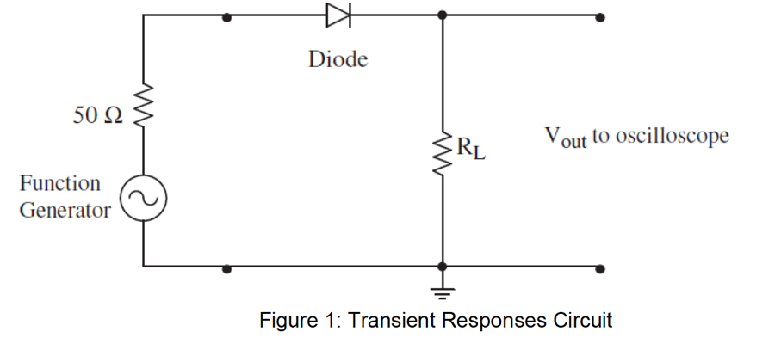

**Data:**

Table 1 p-n Junction Diode 500 kHz

|  |  |  |  |  |  |  |  |  |  |  |  |  |
| --- | --- | --- | --- | --- | --- | --- | --- | --- | --- | --- | --- | --- |
| V offset(V) | Vin(V) | Vout(V) | IF(mA) | IR(mA) | IR/IF | Ts/Tp | IF(mA) | IR(mA) | IR/IF | Ts/Tp | Ts | Tp(s) |
| 1 | 10.8 | 11 | -35.6667 | 2.333333 | -0.06542056075 | 0.78 | -29.02762468 | -9.620523784 | -0.3314264908 | -5.15E-01 | -3.34E-07 | 6.48E-07 |
| 0 | 11 | 11.2 | -35.6667 | 2.33333 | -0.06542056075 | 0.78 | -43.86023517 | -5.206421253 | 0.1187048185 | 1.63E-01 | 1.40E-07 | 8.60E-07 |
| -1 | 12.2 | 9.4 | -35.66667 | 2.333333333 | -0.06542056075 | 0.78 | -40.88375663 | 0.4338684377 | -0.0106122449 | 4.23E-02 | 4.00E-08 | 9.46E-07 |

Table 2 p-n Junction Diode 250 kHz

|  |  |  |  |  |  |  |  |  |  |  |  |  |
| --- | --- | --- | --- | --- | --- | --- | --- | --- | --- | --- | --- | --- |
| V offset(V) | Vin(V) | Vout(V) | IF(mA) | IR(mA) | IR/IF | Ts/Tp | IF(mA) | IR | IR/IF | Ts/Tp | Ts | Tp |
| 0 | 11 | 11 | -35.66666667 | 2.33333 | -0.06542056075 | 0.78 | -40.28301572 | -2.104489578 | 0.0522426025 | -9.94E-08 | 1.80E-07 | -1.81 |

Table 3 Schottkey Diode 250 kHz

|  |  |  |  |  |  |  |  |  |  |  |  |  |
| --- | --- | --- | --- | --- | --- | --- | --- | --- | --- | --- | --- | --- |
| V offset(V) | Vin(V) | Vout(V) | IF(mA) | IR(mA) | IR/IF | Ts/Tp | IF(mA) | IR(mA) | IR/IF | Ts/Tp | Ts | Tp |
| 0 | 11.2 | 11.2 | -34 | 0.66667 | -0.01960784314 | 6 | 1.441742384 | 17.42383752 | 12.08526413 | 1.81E+02 | 2.90E-07 | 1.60E-09 |

Figure 2 Voffset 1V p-n Junction Diode 500 kHz

Figure 3 Voffset 0V p-n Junction Diode 500 kHz

Figure 4 Voffset -1V p-n Junction Diode 500 kHz

Figure 5 Voffset 0V p-n Junction Diode 250 kHz

Figure 6 Voffset 0V p-n Schottky Diode 250 kHz

**Analysis:**

We conducted the experiment using the circuit seen in figure 1 of the procedure. We observed the presence of minority characters and observed that the speed of the minority carriers reacted according to how excited the carriers were. Our P-n @ 500 Khz was observed to perform best when the voltage was set with an offset of -1(figure 2).When the offset is set to 0 the performance of the diode decreases as shown in Figure 3. When set to an offset of 1 volt, the diode performed even worse than with an offset of 0 as seen in Figure 4.

**Discussion:**

The intended PN diode for this experiment was 1N4001, however the diode used instead was 1N485. Both are PN diodes with similar characteristics. The experiment called for a 300Ω resistor load. The nominal and actual values of the often differ, the resistors had a nominal resistance of 300Ω and an actual resistance of 299.36 Ω, a 0.21% percent difference. The ability to measure the Vp (the voltage in positive cycle of the waveform) and the Vn (the voltage in negative cycle of the waveform) was difficult to measure accurately due to the large size of the waveform and the small size of the cursor, to reduce the error the cursor was placed near the same spot in each of the measurements.